|  |  |  |
| --- | --- | --- |
|  | **MARMARA UNIVERSITY**  **FACULTY OF ENGINEERING** |  |

**STRUCTURAL AND CONSEPTUAL DESIGN OF A 3 CYCLINDERS SMALL SIZE DIESEL ENGINE**

**CYLINDER HEAD AND VALVE MECHANISM**

1. Ezgi Altay- 150415005
2. Ufuk Mamikoğlu- 150415055

**ENGINEERING PROJECT-1 FINAL REPORT**

Department of Mechanical Engineering

**Supervisor**

Prof. Dr. Mehmet Zafer Gül

ISTANBUL, Fall 2020

CONTENTS

1. INTRODUCTION 2

2. LITERATURE REVIEW 3

2.1. SI AND CI ENGINES 3

2.2. CYLINDER CONFIGURATIONS IN ENGINES 5

2.3. HISTORY OF THE THREE-CYLINDER ENGINES 6

2.4. TURBOCHARGING TECHNOLOGY 7

2.5. FUEL INJECTION SYSTEMS IN ICE 8

2.6. FUEL CONSUMPTION 8

2.7. THREE-CYLINDER VERSUS FOUR-CYLINDER ENGINES 9

3. MODERN THREE-CYLINDER ENGINE MODELS 11

4. LOTUS ENGINE SIMULATION PROGRAM 21

5. CONCLUSION 23

REFERENCES 23

**List of Figures**

Figure 1: Future of the ICE vehicles and electric vehicles 6

Figure 2: Light duty vehicle forecast 7

Figure 3: Three-cylinder Engine Drawing in Lotus 23

Figure 4: Engine with Turbocharger Drawing in Lotus 23

Figure 5:Engine with Supercharger Drawing in Lotus 24

Figure 6: Lotus drawing of the model engine 26

Figure 7:Performance summary 26

Figure 8:Pressure and temperature graph 27

Figure 9:Input data 27

**List of Tables**

Table 1:Engine Parameters 24

# INTRODUCTION

An engine is a component that converts a form of energy into mechanical energy. One of the most common forms is the internal combustion engine (ICE). The internal combustion engine is a heat engine which converts the chemical energy of a given fuel into mechanical energy. The combustion process with an oxidizer, which is mostly air, takes place in the combustion chamber which is inside the engine. Therefore, the name of the internal combustion engine comes from combustion occurring within the engine. Internal combustion engines are used in large vehicles such as automobiles, trucks, buses, locomotives, marine etc. and in smaller vehicles such as motorbikes. Some other portable devices such as chain saws, lawn mowers are also built with internal combustion engines. Earliest internal combustion engines in the 18th century can be classified as atmospheric engines. The first working atmospheric engine model invented by J.J.E. Lenoir around 1860’s. Until 1870’s, many of those engines were built with power output up to 6 hp (4.5 kW) and mechanical efficiency up to 5%. In 1867, Nicolaus Otto and Eugen Langen introduced the Otto-Langen engine. Their engine’s efficiency was improved up to 11%. Many engine inventors in the 19th century, built different engines operating on the same basic four-stroke cycle and the modern-day engines started to shape. Otto’s engine prototype in 1876 was patented and took credit. It was a four-stroke, one cylinder engine and it took the most credit because it used the first functional compressed charge. The first internal combustion engines appeared in automobiles around 1880’s. Rudolf Diesel had improved his compression ignition engine by 1892 and it is basically today’s modern diesel engine. (Pulkrabek, 2004) This report mainly focuses on diesel, straight three-cylinder engines, the improvements that have been made on three-cylinder engines since they were introduced and the reasons why they are on the rise in the past 10 years.

# LITERATURE REVIEW

## SI AND CI ENGINES

Internal combustion engines can be produced in many different styles which differ in size, volume, geometry, and operating characteristics. These classifications will be explained shortly in the next paragraphs. There are 2 types of ignition in internal combustion engines: spark ignition (SI) and compression ignition (CI). In SI engines, the combustion process in each cycle starts with the help of a spark plug. SI engines mostly use gasoline as their fuel however, they can also run-on natural gas, LPG, and methane. One of the biggest differences between SI and CI engines is the compression ratio. (Pulkrabek, 2004) In CI engines, the air-fuel mixture self-ignites because high compression creates high temperature in the combustion chamber. CI engine are also widely known as diesel engine because they use diesel fuel.

Most internal combustion engines operate on a four-stroke cycle meaning an engine needs four piston strokes to complete a cycle or two-stroke cycle meaning an engine needs two piston strokes to complete a cycle. In four-stroke cycles, the strokes are classified as follows: intake stroke, compression stroke, power stroke and exhaust stroke. The strokes in SI and CI engines are mostly similar with slight differences in intake, compression, and combustion strokes. During the intake stroke, SI engines take air and fuel mixture inside the cylinder. However, in CI engines no fuel is added in the supply air. At the end of the compression stroke in the SI engine, the spark plug is fired, and combustion begins. In CI engine, the compression stroke is very similar to SI engine with the difference of only air being compressed to higher pressure and temperature. At the end of the compression stroke, the fuel is added with injection directly into the combustion chamber. (Pulkrabek, 2004) Another difference in CI and SI engines is the throttle. In SI engines, air fuel flow is controlled by throttles. However, there is no throttle in the manifold of the CI engines. In general, CI engines are considered to be more efficient than the SI engines. One reason is the high compression ratio of CI engines. Their higher compression pressure and corresponding higher temperature lead to higher thermal efficiency. Also having throttles to control the power output reduces the overall engine efficiency in SI engines. (Galen J. Suppes, Truman S. Storvick, 2016) CI engines operating unthrottled also enable them to have high volumetric efficiency because air intake is fully completed when the fuel is injected.

Besides these traditional gasoline or diesel engines, there are also electric vehicles that use electric motors. Electric vehicles can be subcategorized as pure-electric vehicles (battery electric vehicle), hybrid electric vehicles and plug-in hybrid vehicles. Battery electric vehicles are powered by only electric motors whereas hybrid vehicles are powered by an internal combustion engine and an electric engine. Electric vehicles are on the rise in the past years and it is assumed that they will be used a lot more in the future. Their benefits are undeniable however with today’s technology, they have some disadvantages compared to the traditional engines. First of all, they have limited range. Therefore, some problems can be faced when going on long rides. Also, the battery electric vehicle’s recharging process takes a long time. Especially for plug-in hybrid vehicles, charging is even a harder case because charging stations/networks are not as common and available for people. Therefore, it can be stated that today’s market still depends a lot on the traditional SI and CI engines and it is going to need a lot more time and technological improvements until electric vehicles can fully replace internal combustion engines in passenger cars.

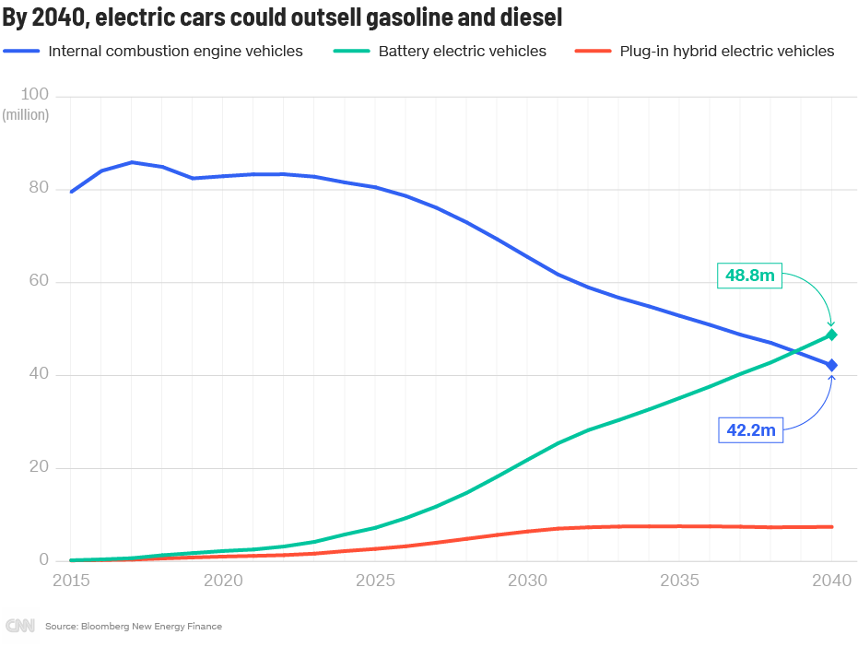

Figure 1: Future of the ICE vehicles and electric vehicles

The figure above shows a prediction of the number of the internal combustion engine vehicles and electric vehicles until 2040 made by Bloomberg New Energy Finance. It can be seen that the number of electric vehicles will increase over the years. However, SI and CI engines are still going to cover many cars. Around the years 2035-2040, almost half of the vehicles are still going to be powered by gasoline or diesel engines. Thus, there will still be a big need for diesel engines for cars in near future.

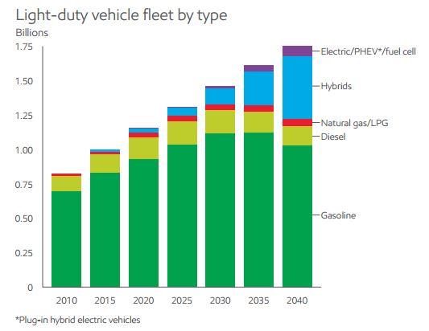

Figure 2: Light duty vehicle forecast

Another prediction is made by research scientist Schalk Cloete. Figure 2.2 shows that although the number of hybrid and electric vehicles are going to increase starting from 2015, the diesel vehicles are still going to be in the market almost as much as they were in 2010.

## CYLINDER CONFIGURATIONS IN ENGINES

There are many different engine cylinder configurations and layouts available in the market since the first internal combustion engines were built. A cylinder is the powerhouse of a car engine, they are the components that run the engine. They are cylindrically shaped spaces in the engine block that have the pistons located in it. When the fuel/air mixture is ignited in the combustion chamber above a piston, it is driven down through the cylinder and, via connecting rods, rotates the crankshaft before being pushed back up to exhaust unburned gases. Common engine layouts can be listed as: straight, in-line, V, flat and W. Straight and in-line engines are mostly used in cars. By their cylinder numbers, the primarily used ones can be listed as: single cylinder, twin-cylinder, three-cylinder, four-cylinder, five-cylinder, six-cylinder, and eight+ cylinder engines (Pulkrabek, 2004). Therefore, they can be as small as a single cylinder or twin-cylinder which has only two cylinders and are mostly used in motorcycles. Four-cylinder engines cover the large majority of small to mid-range cars whereas six and eight-cylinder engines are used on high end performance cars. Five-cylinder engines are very rare and suffer a vibration problem. Similarly, three-cylinder engines also suffer a vibration problem although they were widely used in small cars in the past and they are on the rise again. A straight-three engine is a three-cylinder piston engine where cylinders are arranged in a line along a common crankshaft (Robson, Graham 2010). Three-cylinder engines are being used in both cars and motorcycles for a long while. They are very prevalent especially in motorcycles and small cars because of their smaller size. Typically, a crankshaft angle of 120 degrees is used by three-cylinder engines. However other crankshaft angles also have been used occasionally.

## HISTORY OF THE THREE-CYLINDER ENGINES

The earlier car companies started engine productions with two-cylinder two-stroke engines until three-cylinders were introduced. DKW (Dampf-Kraft-Wagen) is a German car and motorcycle company which was founded in 1916. Their cars were powered by two-cylinder two-stroke engines (models F1 to F8) until they were replaced by the successful three-cylinder engine that came with the F91. In 1939, they made a prototype with the first three-cylinder engine, with a displacement of 900 cc and producing 30 HP (22 kW). The F91 was in production between 1953 and 1955. F91 was replaced by the larger F93 which also had 900 cc three-cylinder two-stroke engines delivering 38 HP (28 kW) (Sedgwick, Michael & Gillies, Mark)

Saab Automobile AB was a Swedish car manufacturer that was founded in 1945. Their first production model Saab 92 used DKW engines in 1949. Saab 92 model with 25 HP was under production for 5-6 years, then they were redesigned and re-engineered in 1955 and renamed as Saab 93. Saab 93 is the first three-cylinder engine with 33 HP (25 kW) of the Saab AB which was also used in Saab 95 and Saab 96 (Chapman, Giles 2009) .

The Wartburg (found in East Germany, dates back to 1898) and FSO Syrena (found in Poland in 1957) are amongst the other first car manufacturers that used a three-cylinder engine. Starting from 1950’s until 1991, Wartburg cars used three-cylinder two-stroke engines. (Schindelbeck, Dirk 2012) The Syrena was produced in various models such as 100, 101,102,103 and 104 between the years 1956-1966, which all used two stroke two-cylinder engines. Starting from 1965, Syrena received a larger three-cylinder engine and started using that one in its models. (Gloor, Roger 2007)

The models that have been discussed above were the first examples of the three-cylinder engines. It can be summarized by stating that the first cars that used three-cylinder engines had power output ranging between 30-40 HP. This value is insignificant compared to current engine models’ capacity. Current small car models that mostly use four-cylinder engines, approximately have 120-130 HP, whereas the mid-sized car models can have up to 170-190 HP. The second part of the paper focuses on the general improvements that are made on engines that made them more powerful and efficient. However, this report will be focusing more on the three-cylinder engines because their increased power output is not the only reason why they became more common over the last years. There are other variables that control the engine market which made three-cylinder engines more preferable over the bigger engines such as four-cylinder.

## TURBOCHARGING TECHNOLOGY

Turbochargers are air pump devices that increase an internal combustion engine's efficiency and power output by compressing the air that the engine can ingest. Compressing the air results in more intake air and fuel mixture in the cylinders and therefore more power would be created. They are commonly used in trucks, cars, trains, and aircrafts. (Nice, Karim 2000) First turbocharger was invented by a Swiss engineer, Alfred J. Büchi in 1905. The first commercial application of a turbocharger was in 1925, when Alfred Büchi successfully installed turbochargers on ten-cylinder diesel engines, increasing the power output from 1,300 to 1,860 kilowatts (1,750 to 2,500 HP). Commercial success of the turbochargers started around 1955. From 1954 to 1969 more than 60% of the trucks and buses sold in Scandinavian market were equipped with turbochargers. However, their application to the automotive field was slow. (Ronan, Larry & Abernathy, William 1979) The first turbocharged cars were the short-lived Chevrolet Corvair Monza and the Oldsmobile Jetfire, introduced in 1962. It was very expensive to produce them and they were not working as efficient and as smoothly as they do nowadays. However, since then, turbocharging technology has advanced greatly to the extent that an engine’s displacement and cylinder number does not necessarily control how powerful it can be. Therefore, it can be stated that the older smaller engines which had not been manufactured with turbochargers were not as powerful as today’s engines thus turbocharging technology allowed smaller sized engines such as three-cylinders to be able to compete with bigger engines and produce as much power.

Besides the turbochargers, there is also another device that is used for the same purpose: superchargers. They are mechanical compressors which compresses the intake air. They also increase the power output. Turbochargers and superchargers are responsible for the big power output increase in engines.

## FUEL INJECTION SYSTEMS IN ICE

It was mentioned earlier that SI and CI engines can differ in operations. Method of fuel injection is another operation that is different in SI and CI engines. Earlier models of SI engines used carburetors for a long while. Carburetion is a primitive technology, and it is mostly replaced by multipoint fuel injectors or throttle body (single) fuel injector in SI engines. These are also called the external mixing systems. In throttle body injection, the injector is mounted above the throttle and injects the fuel towards the center of the intake manifold. However, in multipoint fuel injection, the fuel is injected to the intake ports instead of the intake manifold with multiple injectors. The biggest difference in the CI engines is the place where the fuel is injected. As it was mentioned earlier, the fuel is injected directly into the combustion chamber. It is also called the internal mixing system. Internal mixing can be divided into two subsections: direct and indirect injection. There are two combustion chambers in the indirect injection. The fuel is firstly injected into the secondary chamber and it starts combusting. After that combustion continues in the main combustion chamber. In direct injection, there is one main combustion chamber which the fuel is injected into. (Pulkrabek, 2004) The common direct injection system is the common-rail injection.

Fuel injection systems have a significant influence on the combustion process and they play an important role in improving engine fuel consumption and reducing noxious exhaust emissions. (Doug Woodyard 2009) Also, the fuel injection system has a major effect on the engine’s capacity and power output as well. That motivates researchers and engine manufacturers to constantly improve new fuel injection technologies on the engine to reduce emissions and increase engine’s efficiency. (Van Viet Pham & Duc Thiep Cao 2019) Improved fuel injection systems can control the air to fuel ratio better therefore makes combustion more efficient.

## FUEL CONSUMPTION

A vehicle’s fuel consumption is based primarily on its technology and size; and vehicle size is mainly based on its weight. For example, SUVs consume more energy than the smaller, lighter vehicles. (Internal Energy Agency 2020) Also, the engine is the heaviest component of the car. Therefore, it can be said that the weight of the engine mostly determines the fuel consumption. Consequently, when less fuel is burned; less emission is generated. Passenger cars and vans ('light commercial vehicles') are responsible for around 12% and 2.5%, respectively, of total EU emissions of carbon dioxide (CO2), the main greenhouse gas (Regulation (EU) 2019/631) In 2009, the European Union put in place a corporate average CO2 emissions standard that requires manufacturers to reach target emission levels for cars sold within the EU. On 17 April 2019, the European Parliament and the Council adopted ‘Regulation (EU) 2019/631’ setting CO2 emission performance standards for new passenger cars and for new vans in the EU.The emission regulations are getting stricter with the increasing global warming effect and according to IEA (International Energy Agency)’s sustainable development scenario to 2070, passenger cars and buses are expected to largely stop consuming fossil fuels by the year 2070. Considering the fact that the fossil fuels are finite and with the rate that we are consuming them, they will be depleted soon enough. Therefore, it can be obtained that mandated corporate fuel economy standards, fuel regulations, increasing emission levels and scarcity of the fuels have led the car manufacturers to go for downsizing in passenger cars. As it was mentioned above, a vehicle’s size mostly depends on its engine’s weight, so downsizing a vehicle basically means manufacturing smaller engines or manufacturing engines that have fewer numbers of cylinders. As it was mentioned in the previous paragraph, the turbochargers have proven its capability to increase power output of the conventional engine in an economical way, it has become easier to obtain higher horsepower from smaller engines with the improvements in the turbocharging technology. Overall, it can be said that the turbochargers improved automobile fuel economy without compromising vehicle performance and they contributed majorly to manufacturing smaller engines.

## THREE-CYLINDER VERSUS FOUR-CYLINDER ENGINES

It was stated that the new trend is going towards having smaller engines in the vehicles. One may think that four-cylinder engines are rather small, efficient and are already used commonly in small to midsize cars. Although four-cylinder engine’s advantages are undeniable, three-cylinder engines also have some other advantages over them. Their advantages/disadvantages will be discussed in the incoming parts and comparisons will be made.

Many automobile manufacturers such as Saab Automobile AB, DKW, and The Wartburg had used 2-stroke engines in the past. However, their production ended in 1980-1990’s and nowadays they are being used in small applications such as remote-controlled cars, lawn tools and chainsaws. Thus, it is safe to say that almost all automobile engines are 4-stroke these days. Even numbered and symmetric engines seem easier to understand, easier to balance. This makes a 4-stroke four-cylinder engine’s overall balancing almost perfect. So, the most advantageous aspect of a 4-cylinder engine is that it is extremely refined. Through every stroke made in a 4-cylinder engine, one cylinder is always in the power stroke and the rest are all at different positions than each other. This gives the crankshaft a much more streamlined motion which translates to smooth engine operation overall. On the other hand, a crankshaft angle of 120 degrees is typically used by straight-three engines since this results in an evenly spaced firing interval. The torque over the reciprocating pistons is not matched in unison, therefore the engine tries to rotate and flip over. So, a balancing shaft is needed to counteract this twisting force (Fernie, Micheal 2017). Also due to the difference in the way the pistons are arranged in a 3-cylinder design, the delay of half a cycle between the power strokes exists but this delay is considerably negligible. Overall, the disadvantages of the three-cylinder engines can be listed as being noisier, less responsive, and not refined as the four-cylinders. (Mishra, Martand 2020)

Despite the disadvantages that are given in the previous passage, three-cylinder engines are still able to do more with less. With the improved turbocharging technology, three-cylinder engines can reach high HP values with very little displacements such as 1.2-1.5 L. Therefore, they deliver great performance, and they can now be engineered to take enough boost to bring their output up to four-cylinder levels. (O'Kane, Tony 2020) The biggest advantage of three-cylinders is their better fuel efficiency. This depends on two main factors. One of them is being lightweight and the other one is having less friction. It was mentioned that a car’s fuel consumption is based primarily on its engine’s weight. Having one less cylinder affects majorly on the fuel consumption because due to the absence of one cylinder the engine block is much lighter. Even the crankshaft is lighter and therefore the engine consumes a lesser amount of fuel in the running engine because there is less mass to motivate. Another result of having fewer moving parts is having less internal friction. Less friction is generated because there are fewer cylinders doing metal to metal movements, fewer things rotating and sliding inside the crankcase. This reduces the fuel consumption and gives a better, efficient movement. From the customer’s point of view, less fuel means less money spent on gas. Thus, especially the customers of A,B or C segment cars prefer them instead of four-cylinders.

Producing three-cylinder engines instead of four-cylinders benefits the manufacturer as well. One fourth of the raw materials that are used in four-cylinder engines are not used during the production of three-cylinder engines. Therefore, there is a major gain from the raw materials, but the saving does not just come from this. It mostly comes from the reduced number of operations required to produce and install those engine components both in machine time and human labor. (O'Kane, Tony 2020) Although it can be a few seconds per operation, it makes a considerable difference when every operation adds up.

In conclusion, three-cylinder engines are now able to produce power as much as four-cylinders with the major help from turbochargers. Thus, having less power output is not a concern anymore. It can be also said that the three-cylinder engines benefit both the manufacturer and the customer. They are cheaper to manufacture because less raw material is needed, and they also save on time and human labor because there are fewer operations to complete. From the customer’s point of view, three-cylinders are fuel efficient which means they are more economical than the four-cylinders. They are also cheaper to operate because it costs less to replace the parts when they break down, thus for the long run they are cost-effective. Besides the manufacturers and the customers, three-cylinder engines are better for the environment as well. It was mentioned that three-cylinder engines burn less fuel and less fuel burned means less emission created. Emission levels are reaching a dangerous degree in the past 10 years and passenger cars are responsible for the big portion of the emissions. Therefore, it became crucial that people should act accordingly to decrease the emission levels.

# MODERN THREE-CYLINDER ENGINE MODELS

In the following part, three-cylinder engine examples will be discussed, and their properties will be explained briefly. These engines are mostly CI engines, but some SI engine examples are also given to give a better insight.

**Daihatsu C-series Engine**

This engine is produced by Daihatsu. C-series engines are three-cylinder ICE’s and their displacement is between 843 cc to 993 cc. They are manufactured in both diesel and petrol series. Their engine blocks are produced with cast iron and their cylinder heads are aluminum.

**CL (993 cc diesel)**

CB (993 cc) is the most common SI engine of the C-series in Daihatsu. CL (993 cc) 1.0 L is the diesel version of CB (993 cc). It was introduced in 1983.Its turbocharged version is named as CL50 and it produced 50 hp (37 kW). (Ruiz, Marco 1986)

**Suzuki G Engine**

Suzuki G engine series are three and four-cylinder engines. They are used in Suzuki Samurai and Suzuki Vitara.

**G10**

Turbocharged versions of the G10 model were available in the market between the years 1985-1991.This engine delivered 70 hp (52 kW) at 5500 rpm and 79 lb⋅ft (107 N⋅m) at 3500 rpm. It was produced as carbureted and it received fuel injection in 1987. Its power output went up to 81 hp (60 kW).

**VM Motori Engines**

VM Motori is an Italian company that has designed and built several different diesel engines. It manufactures engines for companies such as GM and Jeep.

**R315 SOHC**

The engine is a 1.5 L (1,493 cc) ICE with a single overhead camshaft, four valves-per-cylinder, and uses common-rail direct fuel injection. It is used in different Hyundai models such as Hyundai Accent, Hyundai Matrix and Hyundai Getz. their power output is 90 hp (60 kW).Improved version was named as RA315 and its power output was improved to 104 hp (77 kW).

**HR 392 SOHC**

The engine is a straight-three, 1.8 L (1,779 cc) and turbocharged. It is designed with two valves per cylinder and its engine block was cast iron, its head was alloy. A Bosch VE3/10 fuel injection pump and a KKK K14 turbocharger were used. This engine is not in production nowadays however it was one of the biggest three-cylinder engines in passenger cars. The Alfa Romeo 33 series used this engine between the years 1986-1990.

*Displacement — 1.8L (1,193 cc)*

*Bore — 92 mm*

*Stroke — 89.2 mm*

*Power — 72 hp (54 kW )*

**Mitsubishi**

**3A92 Engine**

The 3A9 engine series is a three-cylinder engine manufactured by The Mitsubishi. The 3A92 was used in Mitsubishi Mirage from 2012 to 2019. (Mitsubishi Motors Technical Review 2005)

*Displacement — 1.2L (1,193 cc)*

*Bore — 75 mm*

*Stroke — 90 mm*

*Compression—10.5:1*

*Power — 76 hp (57 kW ) at 6,000 rpm*

*Torque — 100 N⋅m (74 lb⋅ft) at 4,000 rpm*

**3G8 Series**

Mitsubishi Motors is the manufacturer of 3G8 engines. It uses advanced technologies such as multi-valve cylinder heads and double overhead camshafts. Mitsubishi was the first manufacturer that used superchargers in 1987. They are SI engines. (Mitsubishi Motors Technical Review 2005)

**3G81 Turbo version**

*Displacement — 548 cc*

*Bore — 62.3 mm*

*Stroke — 60 mm*

*Fuel type — Unleaded regular gasoline*

*Engine type — Inline three-cylinder DOHC 15-valve intercooled turbo*

*Fuel system — ECI multiple*

*Power — 63 hp (47 kW) at 7500 rpm*

*Torque — 75 N⋅m (55 lb⋅ft) at 4500 rpm*

**3G82 Turbo Version**

*Displacement — 657 cc*

*Bore — 65 mm*

*Stroke — 66 mm*

*Fuel type — Unleaded regular gasoline*

*Engine type — Inline three-cylinder DOHC 15-valve intercooled turbo*

*Compression ratio — 8.5:1*

*Fuel system — ECI multiple*

*Power — 63 hp (47 kW ) at 7,500 rpm*

*Torque — 96 N⋅m (71 lb⋅ft) at 4,500 rpm*

**Daewoo S-TEC Engine**

Suzuki and Daewoo Motors developed S-TEC together. The first version was 0.8 L (796 cc).

*Power — 48 hp ( 36 kW) at 6,000 rpm*

*Torque — 71.5N⋅m (52.7 lb⋅ft) at 4,000 rpm*

**GM Family 0 Engine**

The Family 0 is a family of inline piston engines that was developed by Opel.

**X10XE**

*Displacement* — 973 cc

*Bore* — 72.5 mm

*Stroke* — 78.6 mm

*Compression ratio — 10.1:1*

*Power — 54 hp (40.5 kW)*

*Torque — 82 N⋅m (60 lb⋅ft) at 2,800 rpm*

**Z10XE**

*Displacement — 973 cc*

*Bore — 72.5 mm*

*Stroke — 78.6 mm*

*Compression ratio — 10.1:1*

*Power — 57 hp (42.7 kW)*

*Torque — 85 N⋅m (63 lb⋅ft) at 2,800 rpm*

**Mercedes-Benz Engines**

**OM639 Engine**

The OM639 is a turbocharged inline-three diesel engine produced by Mercedes-Benz, in collaboration with Mitsubishi Motors. (Butler, Glenn 2004)

*Displacement — 1.5 L (1,493 cc)*

*Bore — 83 mm*

*Stroke — 92 mm*

*Compression—18:1*

*Power — 94 bhp (70 kW) at 4,000 rpm*

*Torque — 210 N⋅m (155 lb⋅ft) at 1,800 rpm*

**M160 Engine Series**

**M160**

M160 is an inline three-cylinder engine which was produced by Mercedes-Benz for Smart cars between the years 1998 to 2007. A Garrett GT12 turbocharger is used. (Fincham, Chris 2003).

**M160 E06 LA**

It was used inSmart City Coupé from 1998 to 2003, Smart City Cabrio from 2000 to 2003 and Smart Crossblade from 2002 to 2003.

*Displacement* — 0.6L (599 cc)

*Bore* — 63.5 mm

*Stroke — 63 mm*

*Power —71hp (53 kW ) at 5,470rpm*

*Torque — 108 N⋅m (80 lb⋅ft) at 2,200 rpm*

**M160 E07 LA**

It was used in Smart Fortwo from 2003 to 2006, Smart Roadster from 2003 to 2006 and Smart Roadster Brabus from 2004 to 2006.

*Displacement* — 0.67L (698 cc)

*Bore* — 66.5 mm

*Stroke* — 67 mm

*Power — 99hp (74kW ) at 5,250rpm*

*Torque — 130 N⋅m (96 lb⋅ft) at 2,500-5300 rpm*

**Mercedes-Benz OM660**

The OM660 is a turbocharged, three-cylinder, diesel engine manufactured by Mercedes-Benz and it was used in Smart Fortwo cars from 2009 to 2014.

*Displacement — 0.8L (799 cc)*

*Bore — 65.5 mm*

*Stroke — 79 mm*

*Compression—18.5:1*

*Power — 54 hp (40 kW) at 3,800 rpm*

*Torque — 130 N⋅m (96 lb⋅ft) at 2,100rpm*

**Volkswagen Group Diesel Engines**

**1.2 TDI CR EA189**

1.2 TDI CR is a three-cylinder CI engine. It was firstly introduced in Volkswagen Polo in 2009. This engine is the result of the downsizing in the automotive industry. It is turbocharged and Common Rail Delphi 3.7 injection system is used.

*Displacement — 1.2L (1199 cc)*

*Bore — 79.5 mm*

*Stroke — 80.5 mm*

*Compression—16.5:1*

*Power — 74 hp (55 kW)*

**1.4 TDI EA288**

The 1.4 TDI engine is the newer version in the EA288 line. It is a turbocharged, inline three-cylinder, CI engine. Common rail injection system is used, and its block and head are made of aluminum. 1.4 TDI EA288’s production started in 2014 and it is still ongoing. It is used in Audi A1, Seat Ibiza, Toledo IV, Skoda Fabia III and Volkswagen Polo V.

*Displacement — 1.4L (1442 cc)*

*Bore — 79.5 mm*

*Stroke — 95.5 mm*

*Compression—16.1:1*

*Power — 104 hp (77 kW)*

*Torque — 184 N⋅m (96 lb⋅ft) at 2,500rpm*

**1.2 R3 PD TDI 3L**

This is a three-cylinder, turbocharged, CI engine. It is used in Volkswagen Lupo 3L and Audi A2. It is based on the 1.4 TDI version however its components are lighter.

*Power — 60hp ( 45kW ) at 4,000rpm*

*Torque — 140 N⋅m (103 lbf⋅ft) at 1,800-2,400 rpm*

**Honda E0 Engine**

**ECA1**

The ECA1 engine is a three-cylinder, SI engine. It was used in Honda Insight from 2000 to 2006.

*Displacement: 995 cc*

*Bore & stroke: 72.0 mm × 81.5 mm*

*Compression ratio: 10.8:1*

*Power: 72 hp (54 kW)*

*Torque: 12.6 kg⋅m (91 lb⋅ft; 124 N⋅m) / 2000 rpm*

**Hyundai U Engine**

Hyundai U is a series of three and four-cylinder engines CI engines. They are the smallest engines in Hyundai.

**D3FA (1.2L)**

D3FA is a 1.2 L, three-cylinder CI engine produced by Hyundai. Its engine block is made of iron and the cylinder head is made of aluminum. It has four valves per cylinder. They are used in Kia Picanto, Kia Rio ,Hyundai i10 and i20 models.

*Displacement — 1.2L (1,186 cc)*

*Bore — 77.2 mm*

*Stroke — 90 mm*

*Compression—17.3:1*

*Power — 74 hp (55 kW) at 6,000 rpm*

*Torque — 190 N⋅m (140 lb⋅ft) at 4,000 rpm*

**Toyota KR Engine**

**1KR-VE**

The 1KR-VE is an improved version of the 1KR-DE2. It is lighter and compact.

*Displacement — 1.2 L*

*Bore — 71 mm*

*Stroke — 84 mm*

*Compression—11.5:1*

*Power — 68 PS (50 kW; 67 bhp) at 6,000 rpm*

*Torque — 91 N⋅m (67 lb⋅ft) at 4,400 rpm*

**Nissan HR Engine**

The HR engine family is developed by Nissan and Renault. It has three-cylinder and four-cylinder options.

**HR12DDR**

The HR12DDR is a supercharged, 1.2 L three-cylinder engine with direct injection. It is used in 2010 Nissan Micra and 2012 Nissan Note.

*Displacement — 1.2 L (1,198cc)*

*Bore — 72.2 mm*

*Stroke — 73.1 mm*

*Compression—13:1*

*Power — 97 hp ( 72 kW)*

*Torque — 143 N⋅m (105 lbf⋅ft)*

**BMW Engines**

**BMW B37**

BMW B37 is a 1.5 L, three-cylinder CI engine. VGT turbocharger is used.

*Displacement — 1.5 (1,496cc)*

*Bore — 84 mm*

*Stroke — 90 mm*

*Compression—16.5:1*

*Power — 116 PS (85 kW) at 4000 rpm*

*Torque — 270 N⋅m (199 lb⋅ft) at 1750–2250 rpm*

**BMW B38**

B38 is a turbocharged, three-cylinder, SI engine which is produced by BMW. It has been manufactured since 2013.

*Displacement — 1.2 (1,198cc)*

*Bore — 78 mm*

*Stroke — 83.6 mm*

*Compression—11:1*

*Power — 101 hp (75 kW) at 4,250 rpm*

*Torque — 180 N⋅m (133 lb⋅ft) at 1,400–4,000 rpm*

# LOTUS ENGINE SIMULATION PROGRAM

Lotus software is a very helpful American Software company found in Massachusetts, USA which offers simulation tools that enable the user to create models. It can be used to simulate the performance of many different engine types such as two-stroke, four-stroke, gasoline, diesel, naturally aspirated, supercharged, turbocharged and engines with silencer. The figures of some examples of engines have been drawn on Lotus below.

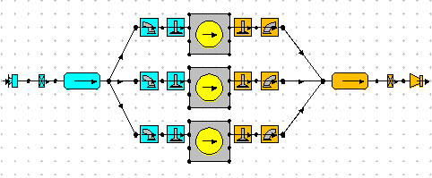

Figure 3: Three-cylinder Engine Drawing in Lotus

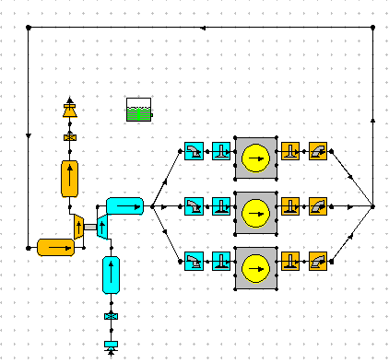

Figure 4: Engine with Turbocharger Drawing in Lotus

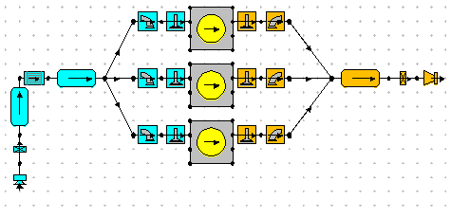

Figure 5:Engine with Supercharger Drawing in Lotus

Supercharging is a technique applied to increase power generation in internal combustion engines. Normally, because of the positive displacement of a piston, air is filled into the cylinder and this air is used in combustion by compressing. The more air that can be fed into the cylinder, the higher the power generated.

# CONCLUSION

It was concluded that three-cylinder engines started to have many advantages over other engines over the years with the new developments made on them. A three-cylinder diesel engine is going to be conceptionally designed in this project. For this matter, an engine model available in the market is going to be chosen and its characteristics are going to be used. Volkswagen’s 1.2 TDI CR EA189 engine is chosen and its parameters are shown in the table below.

Table 1:Engine Parameters

|  |  |
| --- | --- |
| Manufacturer | Volkswagen AG |
| Production years | 2009-2015 |
| Cylinder block material | Cast iron |
| Cylinder heat material | Aluminum |
| Fuel type | Diesel |
| Fuel system | Common rail |
| Configuration | Inline |
| Number of cylinders | 3 |
| Valves per cylinder | 4 |
| Valvetrain layout | DOHC |
| Bore, mm | 79.5 |
| Stroke, mm | 80.5 |
| Displacement, cc | 1199 |
| Type of fuel intake | Turbocharged |
| Stroke | Four-stroke |
| Compression ratio | 16.5:1 |
| Power, hp | 75 |
| Torque, N/m | 180 |
| Firing order | 1-2-3 |

Lotus program is used to draw the engine model which our conceptional design is based on. After that, a simple performance summary graph is made on the program that shows the torque, power BMEP and BSFC values.

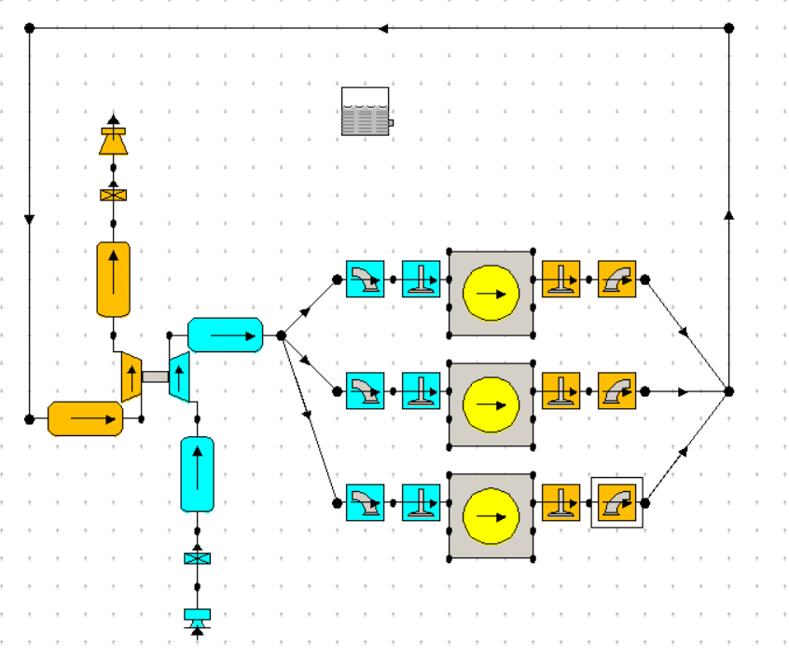

Figure 6: Lotus drawing of the model engine

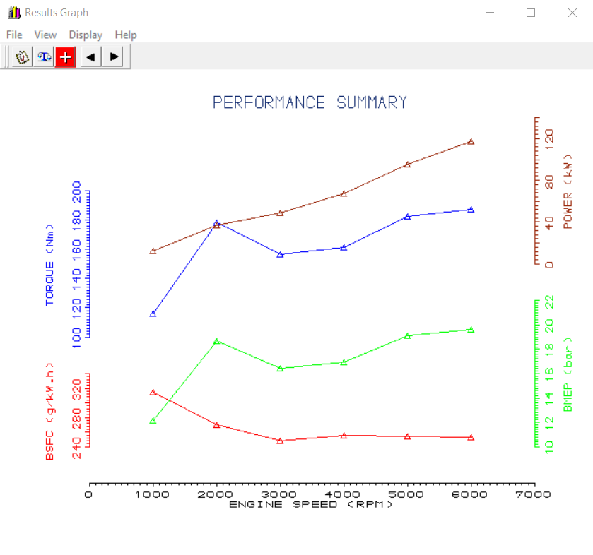

Figure 7:Performance summary

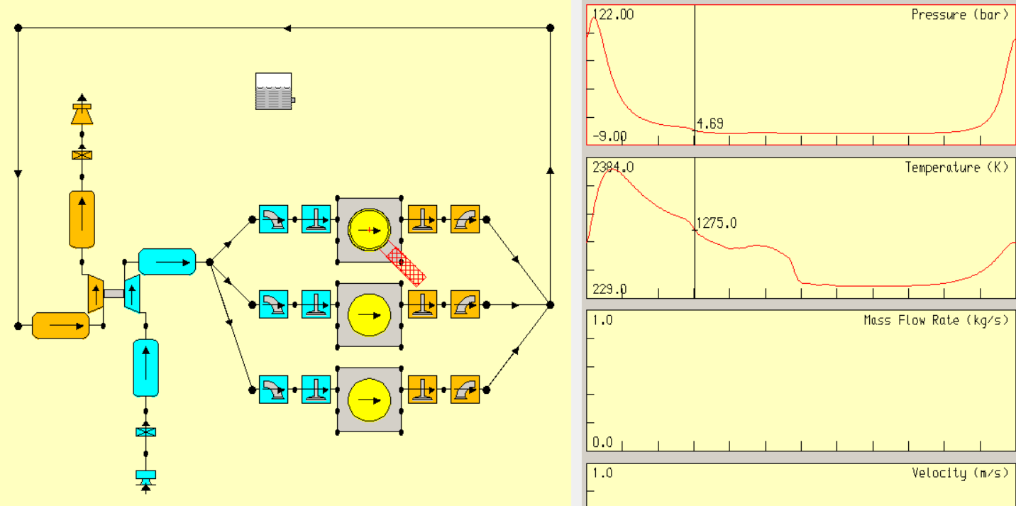

Figure 8:Pressure and temperature graph

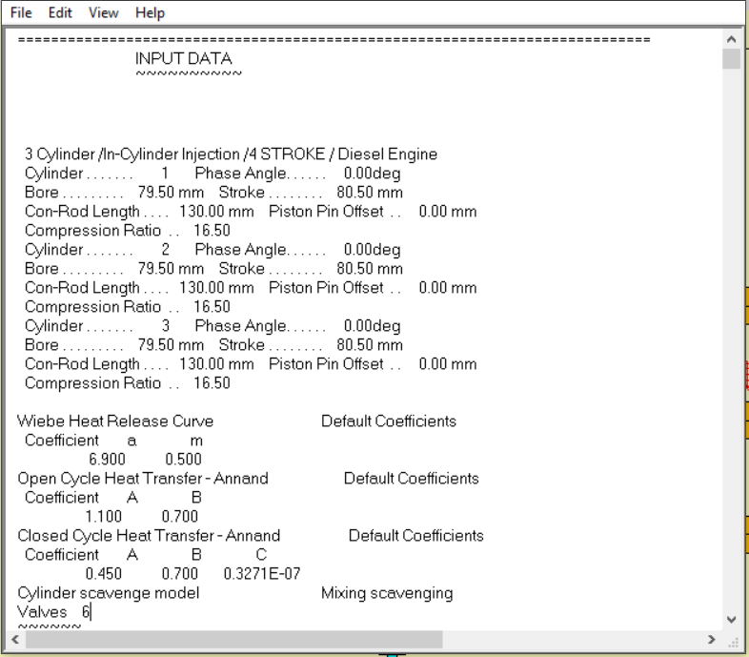

Figure 9:Input data

In the figure above, the input data for the engine can be seen.

# REFERENCES

Pulkrabek, Williard W. (2004) Engineering Fundamentals of the Internal Combustion Engine, Prentice Hall

Galen J. Suppes, Truman S. Storvick, (2016) Sustainable Power Technologies and Infrastructure

Robson, Graham (August 15, 2010). "The car and the team". *Saab 96 & V4*. Rally Giants. Veloce Publishing. p. 27.

Michael Sedgwick & Mark Gillies, A-Z of Cars 1945-1970

Chapman, Giles (May 2009). *The Illustrated Encyclopedia of Extraordinary Automobiles*. Dorling Kindersley. p. 118.

Schindelbeck, Dirk (2012). "Nur keine Nachfrage schaffen" [Never create any demand]. *Damals*

Gloor, Roger (2007). *Alle Autos der 50er Jahre 1945 – 1960* (in German) Motorbuch Verlag.

Nice, Karim (December 4,2000) "How Turbochargers Work",*How Stuff Works*

Ronan, Larry & Abernathy, William (August 1979). The Development and Introduction of the Automotive Turbocharger A Case of Innovation in Response to Fuel Economy Regulation

Doug Woodyard, (2009) Pounder's Marine Diesel Engines and Gas Turbines (Ninth Edition)

Van Viet Pham & Duc Thiep Cao (2019) A Brief Review of Technology Solutions on Fuel Injection System Of Diesel Engine To Increase The Power And Reduce Environmental Pollution

IEA (International Energy Agency) (2020), Fuel Consumption of Cars and Vans, IEA, Paris

CO₂ Emission Performance Standards for Cars and Vans (2020 Onwards), European Commision, Regulation (EU) 2019/631

Fernie, Micheal (2017) "Here's the Problem with Three-Cylinder Engines", *Car Throttle*

Mishra, Martand (January 21,2020) "3 Cylinder vs 4 Cylinder Engine: Performance, Efficiency, Maintenance", *GoMechanic*

O'Kane, Tony (April 06,2020) "Three-cylinder Engines Are Taking Over, and Here's Why ", *Which Car*

Ruiz, Marco (1986). 'The Complete History of the Japanese Car: 1907 to the Present.

Butler, Glenn (2004). "Smart for Four (2004-)", *motoring.com.au*

Fincham, Chris (2003). "Smart City Coupe and Cabrio" *motoring.com.au*